**Concussion**

Concussions are common injuries, especially among young athletes. Most people recover without long-term effects, but it’s important not to rush your recovery. Don’t resume physical or other activities before your healthcare provider says it’s safe.

**Overview**

Let's Talk Concussion.

**What is a concussion?**

A concussion is a [head injury](https://my.clevelandclinic.org/health/diseases/head-injury) that happens when your [brain](https://my.clevelandclinic.org/health/body/22638-brain) moves or twists inside your skull. Concussions are a type of [traumatic brain injury](https://my.clevelandclinic.org/health/diseases/8874-traumatic-brain-injury). They’re some of the most common (and most commonly misunderstood) injuries that people experience.

Almost everyone’s heard of someone “getting their bell rung” or “seeing stars” after a hit. Those phrases might make it seem like concussions aren’t a big deal. And it’s true that concussions aren’t usually life-threatening. But the effects can be serious and last for days, weeks or even longer.

One concussion usually doesn’t cause permanent brain damage. But experiencing multiple concussions over a lifetime can change your brain’s structure or how it works, which can lead to severe complications and increase your risk of developing serious health conditions.

**How common are concussions?**

Concussions are very common injuries. Experts estimate that between 1 and 3 million people visit the emergency room with a concussion in the U.S. each year.

They’re especially common in young athletes. In fact, concussions account for more than half of ER visits for kids ages 5 to 18 every year in the U.S.

**Symptoms and Causes**

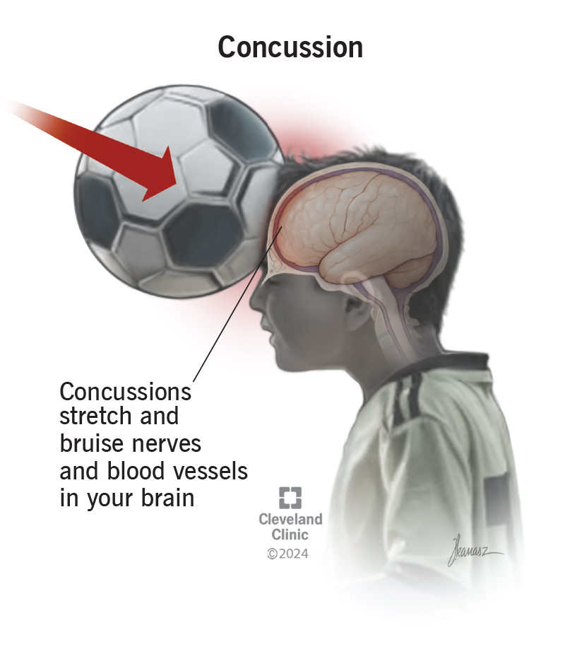Concussions are common sports injuries, but anything that suddenly jerks your body, head or neck can cause one.

**What are concussion symptoms?**

Concussions stretch and injure [nerves](https://my.clevelandclinic.org/health/body/22584-nerves) and [blood vessels](https://my.clevelandclinic.org/health/body/21640-blood-vessels) in your brain. They cause chemical changes that temporarily make your brain stop working like it should. Your brain will automatically redirect all its energy to healing itself after an injury. It will send signals to your body to get you to slow down and avoid activities. That’s where concussion symptoms come from. They’re your brain’s way of telling you to take it easy while it heals.

Concussion symptoms can affect your:

* Physical body.
* Cognitive function (your thinking and how your brain works).
* [Sleep](https://my.clevelandclinic.org/health/body/12148-sleep-basics).
* Emotions and feelings.

Concussion symptoms may start right away. But some people don’t experience symptoms for hours, or even days.

Physical concussion symptoms are usually the most obvious and can include:

* [Headaches](https://my.clevelandclinic.org/health/diseases/9639-headaches) or a feeling of pressure in your head.
* [Neck pain](https://my.clevelandclinic.org/health/symptoms/21179-neck-pain).
* [Balance problems](https://my.clevelandclinic.org/health/symptoms/21021-balance-problems) (including [dizziness](https://my.clevelandclinic.org/health/symptoms/6422-dizziness)).
* A feeling of lightheadedness.
* [Nausea and vomiting](https://my.clevelandclinic.org/health/symptoms/8106-nausea--vomiting).
* [Double vision (diplopia)](https://my.clevelandclinic.org/health/diseases/22203-diplopia-double-vision).
* [Blurred vision](https://my.clevelandclinic.org/health/symptoms/24262-blurred-vision).
* [Sensitivity to light (photophobia)](https://my.clevelandclinic.org/health/symptoms/photophobia).
* [Hearing a ringing in your ears (tinnitus)](https://my.clevelandclinic.org/health/symptoms/14164-tinnitus).
* [Sensitivity to sounds (hyperacusis)](https://my.clevelandclinic.org/health/diseases/24320-hyperacusis).
* Temporary loss of consciousness ([fainting](https://my.clevelandclinic.org/health/symptoms/21699-fainting) or passing out).

Your cognitive function is how well your brain works and controls the rest of your body. A concussion can interfere with your brain’s normal function and cause:

* [Confusion](https://my.clevelandclinic.org/health/symptoms/25206-confusion).
* Feeling like you’re in a fog or not like your usual self.
* Trouble concentrating or focusing.
* [Amnesia](https://my.clevelandclinic.org/health/diseases/21455-amnesia) or short-term memory loss.

Your brain controls your body’s natural sleep cycles (your [circadian rhythm](https://my.clevelandclinic.org/health/articles/circadian-rhythm)). It tells your body when to feel sleepy and when to wake up. A concussion can disrupt those normal rhythms, including making you:

* Feel drowsy or [fatigued](https://my.clevelandclinic.org/health/symptoms/21206-fatigue).
* Have trouble falling or staying asleep.
* Sleep less than usual.
* Sleep more than usual.

A concussion is a physical injury that can affect your mental and emotional health. Emotional concussion symptoms can include:

* Irritability.
* [Mood swings](https://my.clevelandclinic.org/health/symptoms/mood-swings).
* [Depression](https://my.clevelandclinic.org/health/diseases/9290-depression) or sadness.
* New or increased [anxiety](https://my.clevelandclinic.org/health/diseases/9536-anxiety-disorders) or feeling nervous.

**Concussion symptoms in babies and young children**

Babies and kids who aren’t old enough to talk or communicate can still experience concussions. But it can be hard to know what they’re experiencing because they can’t tell you what happened or how they feel. In addition to any of the symptoms above, your child may show other signs of a concussion, including:

* Fussing or crying more than usual.
* Refusing to eat or nurse.
* A blank stare.
* Being unusually irritable or cranky, even when they’ve had their usual amount of sleep or naps.
* Sudden changes in their sleeping patterns, including not falling asleep like usual or being sleepy at unusual times.

**What does a concussion feel like?**

Everyone experiences concussion symptoms differently. But almost everyone has a headache after a concussion. It might be hard to explain, but in addition to any physical symptoms you notice, you’ll probably feel like something is “off.” You may feel dazed, stunned or like you’re in a fog. It might feel like thinking or concentrating takes effort in ways they usually don’t. Visit a healthcare provider if you hit your head and notice that you don’t quite feel like yourself.

**What causes concussions?**

Concussions happen when something jolts or shakes your body. If the force is strong enough, it can make your brain move back and forth or side to side and damage it.

Your brain tissue is soft and squishy. It’s surrounded by cerebrospinal fluid, which acts like a liquid cushion between it and your skull. Picture a glass bowl of gelatin. If you smack the bowl hard enough, the energy passes through the glass into the gelatin and makes it jiggle.

That energy transfer is what happens when you get a concussion. A strong force hits your head, neck or body, moves through your skull into your brain and makes your brain shake or wiggle. This force can twist and damage the tiny nerves and blood vessels in your brain.

The most common causes of concussions include:

* Falls.
* Motor vehicle accidents.
* Bike accidents.
* Physical violence like fights or assaults.
* [Sports injuries](https://my.clevelandclinic.org/health/diseases/22093-sports-injuries).

**What are the risk factors?**

Anyone can experience a concussion. People who have an increased concussion risk include:

* People older than 65 or children younger than 4 (or anyone with an increased risk of falling).
* People with physically demanding jobs like carpentry, landscaping or construction.
* Teens and adolescents.
* Athletes who play physically demanding or contact sports.
* Anyone who’s had a concussion in the past.

Teens experience more concussions than any other age group. Researchers think this is because their brains and bodies are still developing, and they don’t always have full control of their coordination.

**What are complications of a concussion?**

Concussions (especially repeated concussions) can cause some serious complications.

[Post-concussion syndrome (PCS)](https://my.clevelandclinic.org/health/diseases/24900-post-concussion-syndrome) happens when recovering from a concussion takes an unusually long time. You might experience symptoms for much longer than usual (four months, a year or even longer) after the original injury.

Other complications are rare, but can include:

* [Bleeding inside your skull or brain (intracranial hemorrhage)](https://my.clevelandclinic.org/health/diseases/14480-brain-bleed-hemorrhage-intracranial-hemorrhage).
* [Swelling in your brain (cerebral edema)](https://my.clevelandclinic.org/health/diseases/cerebral-edema-brain-swelling).
* Midline shift (your brain moving off-center inside your skull).
* [Skull fractures](https://my.clevelandclinic.org/health/diseases/skull-fracture).

People who’ve experienced one concussion have an increased risk for another, more serious concussion if they return to physical activities or sports too soon. Providers call this second-impact syndrome (SIS). SIS increases your risk of severe complications like brain swelling and bleeding. SIS can be fatal.

Experiencing multiple concussions and other head injuries increases your risk of [chronic traumatic encephalopathy (CTE)](https://my.clevelandclinic.org/health/diseases/17686-chronic-traumatic-encephalopathy-cte). CTE affects how areas of your brain function, communicate and work with each other.

Repeated concussions may also increase your risk of other health conditions, including:

* Depression or other mental health conditions.
* [Dementia](https://my.clevelandclinic.org/health/diseases/9170-dementia).
* [Memory loss](https://my.clevelandclinic.org/health/symptoms/11826-memory-loss).

**Diagnosis and Tests**

**How do you know if you have a concussion?**

Only a healthcare provider can diagnose a concussion. It’s important to visit a provider if you hit your head, experience an injury or think you have any concussion symptoms.

Your provider will diagnose a concussion with a [physical exam](https://my.clevelandclinic.org/health/diagnostics/17366-physical-examination), a [neurological exam](https://my.clevelandclinic.org/health/diagnostics/22664-neurological-exam) or a specific [concussion test](https://my.clevelandclinic.org/health/diagnostics/22267-concussion-test). They’ll ask about any symptoms you’re experiencing and when they first started. Tell your provider if you know the exact moment or injury that caused your symptoms, and how long it took symptoms to develop after the injury or hit to the head.

During your exam, your provider will check your:

* Reflexes, balance, coordination and other neurological functions.
* [Vision](https://my.clevelandclinic.org/health/articles/21204-vision), including your [eye reflexes](https://my.clevelandclinic.org/health/articles/24674-reflexes-of-the-eye) and your response and sensitivity to light.
* [Hearing](https://my.clevelandclinic.org/health/articles/17054-hearing).
* Strength.
* Neck and [neck muscles](https://my.clevelandclinic.org/health/body/21670-neck-muscles).

Your provider may give you tests or puzzles to evaluate your:

* Problem-solving skills.
* Memory.
* Ability to concentrate

These tests may be written, verbal (spoken out loud) or technology-based (like on a computer or tablet).

Tell your provider if any part of the exam feels unusually hard or makes the symptoms worse. You know your mind and body better than anyone, and you can help point out if your balance is worse than usual or if it’s taking you much longer than normal to complete a puzzle.

Imaging tests can’t diagnose a concussion, but your provider may recommend a [CT scan](https://my.clevelandclinic.org/health/diagnostics/4808-ct-computed-tomography-scan) (computed tomography scan) or [MRI](https://my.clevelandclinic.org/health/diagnostics/4876-magnetic-resonance-imaging-mri) (magnetic resonance imaging) to look for serious complications like bleeding in or around your brain.

**Management and Treatment**

**How do you treat a concussion?**

Rest is the most important part of treating a concussion, especially at first. Your brain and body need time to heal. You’ll need to take a break from all intense physical exercise — especially the sport or activity that caused the concussion.

Most people need at least a few days of little or no activity. But everyone’s needs are different, and everyone’s brains heal at different rates. Your provider will recommend how long to rest, and when it’s safe to slowly resume physical or mentally challenging activities.

Learn to recognize the triggers that bring on concussion symptoms. Start adding activities back to your daily routine slowly, in small amounts. When symptoms occur, back off and rest. Once you feel better, you can attempt the activity again. But be prepared to take another break if the symptoms return.

Pace yourself. Don’t push your body to do things that make you feel worse — it’s OK to take the time you need to rest and heal. Limit any activities that worsen your symptoms.

**What should you not do after a concussion?**

Any activity that takes a lot of concentration may trigger concussion symptoms. Especially for the first day or two after a concussion, you may need to avoid:

* Using your phone.
* Watching TV.
* Playing video games.
* Reading.
* Studying.
* Working.
* Physical activity or exercise.

Your provider may recommend that you take time off work, or that your child stay home for school for a few days. They’ll tell you when it’s okay to gradually ease back into working or doing schoolwork based on how long it takes the symptoms to get better.

You may also need to avoid:

* Driving.
* Traveling or taking public transportation.
* Doing certain chores around your home or in your yard.
* Drinking alcohol.

**Can you sleep with a concussion?**

Yes, sleep is an extremely important part of recovering from a concussion.

It’s a common myth that you shouldn’t let someone with a concussion fall (or stay) asleep. Another common myth is that you have to wake someone with a concussion up every few hours or at a set interval to make sure they’re OK. Both of these are outdated assumptions and aren’t true or necessary.

Sleep as often and as long as you naturally feel the need to. If you’re caring for someone with a concussion, it’s OK to check on them every few hours to make sure they’re breathing normally and not tossing and turning restlessly. But you don’t need to forcibly wake them up.

**Can you take medication with a concussion?**

You shouldn’t take any over-the-counter (OTC) [pain medications](https://my.clevelandclinic.org/health/treatments/12058-pain-relievers) if you think you have a concussion before you see a healthcare provider. Many of these medications thin your blood, which can be extremely dangerous if you have a brain bleed.

Your provider will tell you which medications are safe to take while you recover. You may have to avoid [NSAIDs](https://my.clevelandclinic.org/health/treatments/11086-non-steroidal-anti-inflammatory-medicines-nsaids) like naproxen or ibuprofen, but it may be safe to take [acetaminophen](https://my.clevelandclinic.org/health/drugs/18829-acetaminophen-capsules-or-tablets).

Tell your provider which prescription medications you take and any over-the-counter supplements you use. They’ll tell you if you need to avoid or stop any of them while you recover.

**Prevention**

**How can you prevent concussions?**

Concussions are injuries that happen suddenly. Because you can’t plan for them, you may not always be able to prevent one. These general safety tips may reduce your risk:

* Wear the right protective equipment for all activities and sports, especially helmets or protective headwear.
* Always wear your seatbelt.
* Make sure your home and workspace are free of clutter that could trip you or others.
* Always use the proper tools or equipment at home to reach things. Never stand on chairs, tables or countertops.

**Outlook / Prognosis**

**How long does a concussion last?**

Concussions usually last a few weeks, up to a month. But everyone’s bodies respond to concussions differently. Some people naturally heal faster, and others take more time. This usually doesn’t mean you’re more or less likely to experience complications.

How long it takes your brain to heal will depend on a few factors, including:

* What caused the concussion.
* If you experienced any other injuries.
* If you develop any complications.
* How severe the symptoms you experience are.

Talk to your provider before resuming your usual daily routine. Don’t return to exercise, training or playing sports until your provider says it’s safe. Giving your body the time it needs to heal doesn’t mean you’re weak. And rushing your recovery to get back to practice, games or training doesn’t mean you’re extra tough. Your brain will heal at its own pace, and the only thing you can do to help it along is rest.

**Living With**

**When should you go to the emergency room for a concussion?**

Go to the emergency room if you experience a head injury and have any concussion symptoms, even if they don’t start for hours or days.

Go to the ER or call 911 (or your local emergency services number) right away if you experience any of the following symptoms:

* A severe headache that keeps getting worse.
* [Seizures](https://my.clevelandclinic.org/health/diseases/22789-seizure).
* Loss of consciousness.
* Severe dizziness, loss of balance or trouble walking.
* Vomiting more than once.
* Severe confusion (including trouble recognizing people or places).
* Clear, watery discharge from your nose or ears
* Bleeding from your ears.
* Numbness, weakness or tingling in your arms or legs.
* Slurred speech.
* One of your [pupils](https://my.clevelandclinic.org/health/body/24317-pupil-of-the-eye) is bigger than the other ([anisocoria](https://my.clevelandclinic.org/health/diseases/22422-anisocoria)).

These symptoms can all be signs of a severe complication like a brain bleed.

**Which questions should I ask my doctor?**

You may want to ask your provider:

* Which tests will I need?
* What’s my risk of complications?
* Which symptoms should I keep an eye out for?
* How long should I rest?
* What are safe activities for me to do while I recover?

**A note from Cleveland Clinic**

Your brain and body are totally unique to you. And that means how you experience and recover from a concussion will be, too. Recovery doesn’t always happen in a way that we’d expect — it might take more or less time at certain stages. Be honest with yourself and your healthcare providers as you recover.

It’s scary to think about having a brain injury — especially if your child gets a concussion. But most people can recover with no long-term effects or complications. Don’t rush your recovery — the best thing for your brain is to give it all the time it naturally needs to heal itself.

